**Mapping data flows in Azure Data Factory**

## What are mapping data flows?

Mapping data flows are visually designed data transformations in Azure Data Factory. Data flows allow data engineers to develop data transformation logic without writing code. The resulting data flows are executed as activities within Azure Data Factory pipelines that use scaled-out Apache Spark clusters. Data flow activities can be operationalized using existing Azure Data Factory scheduling, control, flow, and monitoring capabilities.

Mapping data flows provide an entirely visual experience with no coding required. Your data flows run on ADF-managed execution clusters for scaled-out data processing. Azure Data Factory handles all the code translation, path optimization, and execution of your data flow jobs.

## Getting started

Data flows are created from the factory resources pane like pipelines and datasets. To create a data flow, select the plus sign next to **Factory Resources**, and then select **Data Flow**.

This action takes you to the data flow canvas, where you can create your transformation logic. Select **Add source** to start configuring your source transformation.

## Authoring data flows

Mapping data flow has a unique authoring canvas designed to make building transformation logic easy. The data flow canvas is separated into three parts: the top bar, the graph, and the configuration panel.

### Graph

The graph displays the transformation stream. It shows the lineage of source data as it flows into one or more sinks. To add a new source, select **Add source**. To add a new transformation, select the plus sign on the lower right of an existing transformation.

### Configuration panel

The configuration panel shows the settings specific to the currently selected transformation. If no transformation is selected, it shows the data flow. In the overall data flow configuration, you can add parameters via the **Parameters** tab.

Each transformation contains at least four configuration tabs.

#### Transformation settings

The first tab in each transformation's configuration pane contains the settings specific to that transformation. For more information, see that transformation's documentation page.

#### Optimize

The **Optimize** tab contains settings to configure partitioning schemes.

#### Inspect

The **Inspect** tab provides a view into the metadata of the data stream that you're transforming. You can see column counts, the columns changed, the columns added, data types, the column order, and column references. **Inspect** is a read-only view of your metadata. You don't need to have debug mode enabled to see metadata in the **Inspect** pane.

As you change the shape of your data through transformations, you'll see the metadata changes flow in the **Inspect** pane. If there isn't a defined schema in your source transformation, then metadata won't be visible in the **Inspect** pane. Lack of metadata is common in schema drift scenarios.

#### Data preview

If debug mode is on, the **Data Preview** tab gives you an interactive snapshot of the data at each transform.

### Top bar

The top bar contains actions that affect the whole data flow, like saving and validation. You can view the underlying JSON code and data flow script of your transformation logic as well.

## Available transformations

## Data flow data types

* array
* binary
* boolean
* complex
* decimal (includes precision)
* date
* float
* integer
* long
* map
* short
* string
* timestamp

## Data flow activity

Mapping data flows are operationalized within ADF pipelines using the data flow activity. All a user has to do is specify which integration runtime to use and pass in parameter values.

## Debug mode

Debug mode allows you to interactively see the results of each transformation step while you build and debug your data flows. The debug session can be used both in when building your data flow logic and running pipeline debug runs with data flow activities.

## Monitoring data flows

Mapping data flow integrates with existing Azure Data Factory monitoring capabilities.

## Available regions

Mapping data flows are available in the following regions in ADF:

| **AVAILABLE REGIONS** | |
| --- | --- |
| **Azure region** | **Data flows in ADF** |
| Australia Central |  |
| Australia Central 2 |  |
| Australia East | ✓ |
| Australia Southeast | ✓ |
| Brazil South | ✓ |
| Canada Central | ✓ |
| Central India | ✓ |
| Central US | ✓ |
| China East |  |
| China East 2 |  |
| China Non-Regional |  |
| China North | ✓ |
| China North 2 | ✓ |
| East Asia | ✓ |
| East US | ✓ |
| East US 2 | ✓ |
| France Central | ✓ |
| France South |  |
| Germany Central (Sovereign) |  |
| Germany Non-Regional (Sovereign) |  |
| Germany North (Public) |  |
| Germany Northeast (Sovereign) |  |
| Germany West Central (Public) |  |
| Japan East | ✓ |
| Japan West |  |
| Korea Central | ✓ |
| Korea South |  |
| North Central US | ✓ |
| North Europe | ✓ |
| Norway East | ✓ |
| Norway West |  |
| South Africa North | ✓ |
| South Africa West |  |
| South Central US |  |
| South India |  |
| Southeast Asia | ✓ |
| Switzerland North | ✓ |
| Switzerland West |  |
| UAE Central |  |
| UAE North | ✓ |
| UK South | ✓ |
| UK West |  |
| US DoD Central |  |
| US DoD East |  |
| US Gov Arizona | ✓ |
| US Gov Non-Regional |  |
| US Gov Texas |  |
| US Gov Virginia | ✓ |
| West Central US |  |
| West Europe | ✓ |
| West India |  |
| West US | ✓ |
| West US 2 | ✓ |

# Transform data using mapping data flows

In this tutorial, you do the following steps:

* Create a data factory.
* Create a pipeline with a Data Flow activity.
* Build a mapping data flow with four transformations.
* Test run the pipeline.
* Monitor a Data Flow activity

## Prerequisites

The file that we are transforming in this tutorial is MoviesDB.csv, which can be found [here](https://raw.githubusercontent.com/djpmsft/adf-ready-demo/master/moviesDB.csv). To retrieve the file from GitHub, copy the contents to a text editor of your choice to save locally as a .csv file. To upload the file to your storage account, see Upload blobs with the Azure portal. The examples will be referencing a container named 'sample-data'.

## Create a data factory

In this step, you create a data factory and open the Data Factory UX to create a pipeline in the data factory.

1. Open **Microsoft Edge** or **Google Chrome**. Currently, Data Factory UI is supported only in the Microsoft Edge and Google Chrome web browsers.
2. On the left menu, select **Create a resource** > **Integration** > **Data Factory**:

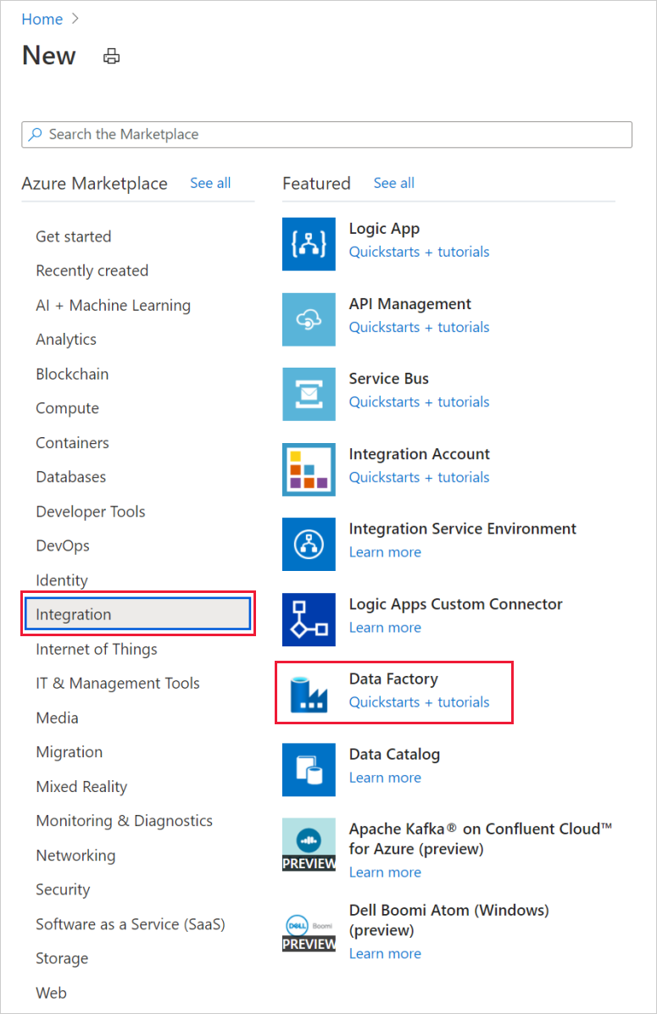

1. On the **New data factory** page, under **Name**, enter **ADFTutorialDataFactory**.

The name of the Azure data factory must be globally unique. If you receive an error message about the name value, enter a different name for the data factory. (for example, yournameADFTutorialDataFactory).

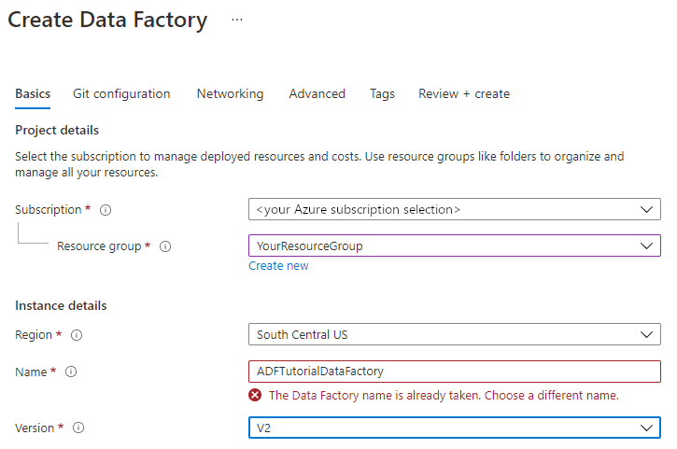

1. Select the Azure **subscription** in which you want to create the data factory.
2. For **Resource Group**, take one of the following steps:

a. Select **Use existing**, and select an existing resource group from the drop-down list.

b. Select **Create new**, and enter the name of a resource group.

1. Under **Version**, select **V2**.
2. Under **Location**, select a location for the data factory. Only locations that are supported are displayed in the drop-down list. Data stores (for example, Azure Storage and SQL Database) and computes (for example, Azure HDInsight) used by the data factory can be in other regions.
3. Select **Create**.
4. After the creation is finished, you see the notice in Notifications center. Select **Go to resource** to navigate to the Data factory page.
5. Select **Author & Monitor** to launch the Data Factory UI in a separate tab.

## Create a pipeline with a Data Flow activity

In this step, you'll create a pipeline that contains a Data Flow activity.

1. On the home page of Azure Data Factory, select **Orchestrate**.

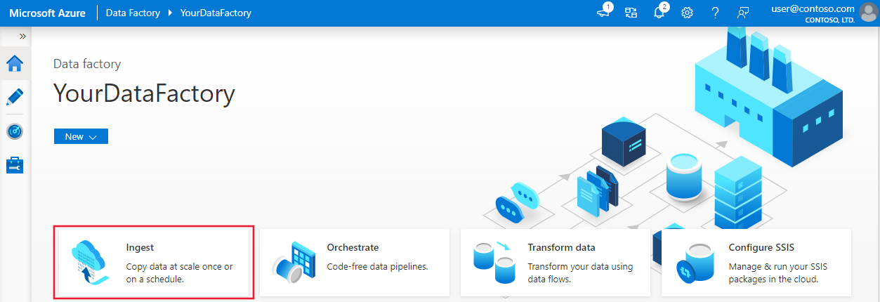

1. In the **General** tab for the pipeline, enter **TransformMovies** for **Name** of the pipeline.
2. In the **Activities** pane, expand the **Move and Transform** accordion. Drag and drop the **Data Flow** activity from the pane to the pipeline canvas.

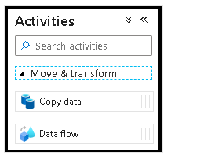

1. In the **Adding Data Flow** pop-up, select **Create new Data Flow** and then name your data flow **TransformMovies**. Click Finish when done.

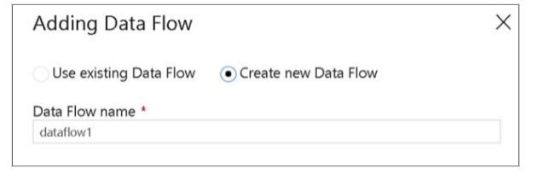

1. In the top bar of the pipeline canvas, slide the **Data Flow debug** slider on. Debug mode allows for interactive testing of transformation logic against a live Spark cluster. Data Flow clusters take 5-7 minutes to warm up and users are recommended to turn on debug first if they plan to do Data Flow development.

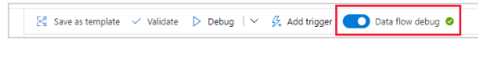

## Build transformation logic in the data flow canvas

Once you create your Data Flow, you'll be automatically sent to the data flow canvas. In this step, you'll build a data flow that takes the moviesDB.csv in ADLS storage and aggregates the average rating of comedies from 1910 to 2000. You'll then write this file back to the ADLS storage.

1. In the data flow canvas, add a source by clicking on the **Add Source** box.

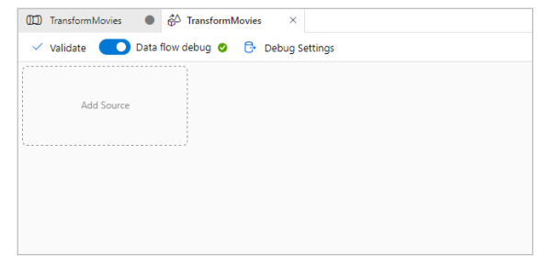

1. Name your source **MoviesDB**. Click on **New** to create a new source dataset.

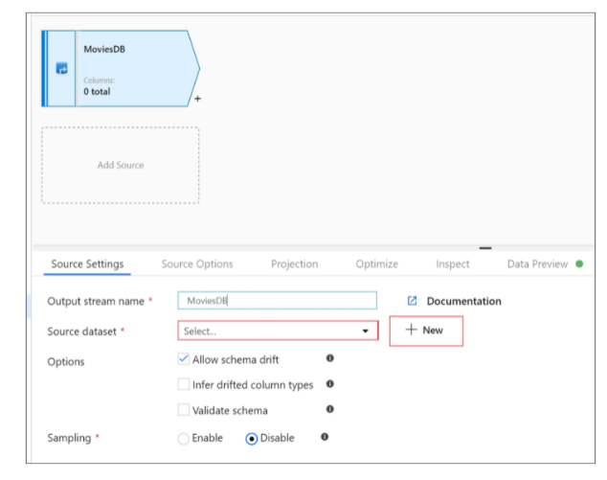

1. Choose **Azure Data Lake Storage Gen2**. Click Continue.
2. Choose **DelimitedText**. Click Continue.
3. Name your dataset **MoviesDB**. In the linked service dropdown, choose **New**.

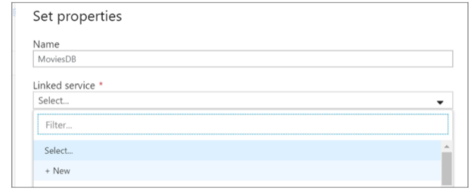

1. In the linked service creation screen, name your ADLS gen2 linked service **ADLSGen2** and specify your authentication method. Then enter your connection credentials. In this tutorial, we're using Account key to connect to our storage account. You can click **Test connection** to verify your credentials were entered correctly. Click Create when finished.

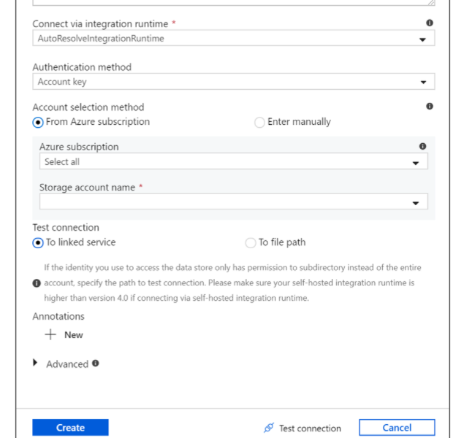

1. Once you're back at the dataset creation screen, enter where your file is located under the **File path** field. In this tutorial, the file moviesDB.csv is located in container sample-data. As the file has headers, check **First row as header**. Select **From connection/store** to import the header schema directly from the file in storage. Click OK when done.

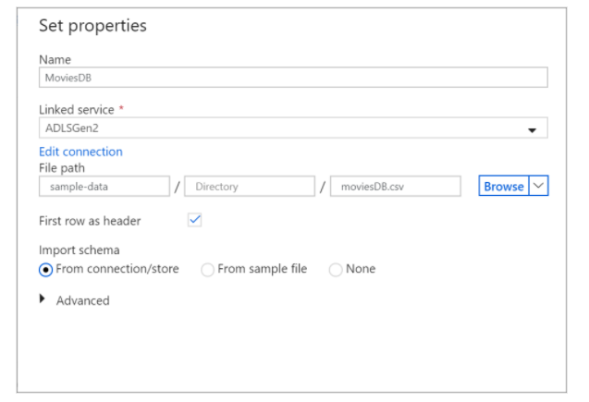

1. If your debug cluster has started, go to the **Data Preview** tab of the source transformation and click **Refresh** to get a snapshot of the data. You can use data preview to verify your transformation is configured correctly.

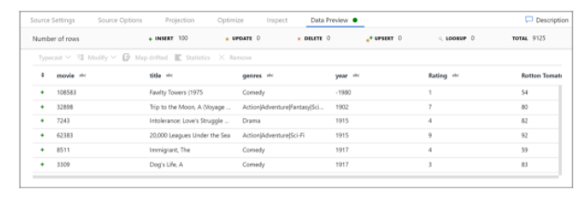

1. Next to your source node on the data flow canvas, click on the plus icon to add a new transformation. The first transformation you're adding is a **Filter**.

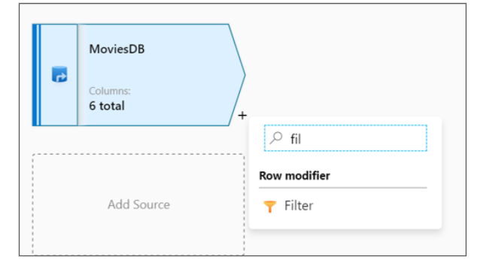

1. Name your filter transformation **FilterYears**. Click on the expression box next to **Filter on** to open the expression builder. Here you'll specify your filtering condition.

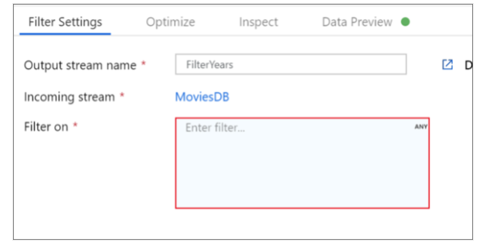

1. The data flow expression builder lets you interactively build expressions to use in various transformations. Expressions can include built-in functions, columns from the input schema, and user-defined parameters.

In this tutorial, you want to filter movies of genre comedy that came out between the years 1910 and 2000. As year is currently a string, you need to convert it to an integer using the toInteger() function. Use the greater than or equals to (>=) and less than or equals to (<=) operators to compare against literal year values 1910 and 2000. Union these expressions together with the and (&&) operator. The expression comes out as:

toInteger(year) >= 1910 && toInteger(year) <= 2000

To find which movies are comedies, you can use the rlike() function to find pattern 'Comedy' in the column genres. Union the rlike expression with the year comparison to get:

toInteger(year) >= 1910 && toInteger(year) <= 2000 && rlike(genres, 'Comedy')

If you've a debug cluster active, you can verify your logic by clicking **Refresh** to see expression output compared to the inputs used. There's more than one right answer on how you can accomplish this logic using the data flow expression language.

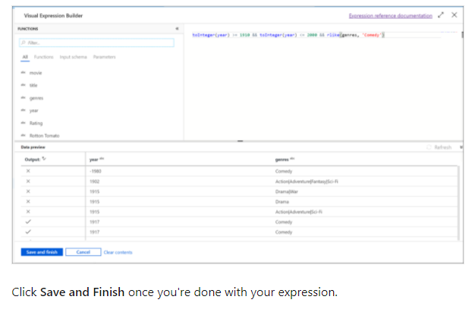

Click **Save and Finish** once you're done with your expression.

1. Fetch a **Data Preview** to verify the filter is working correctly.

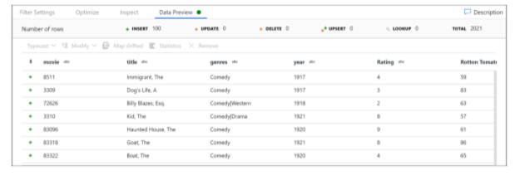

1. The next transformation you'll add is an **Aggregate** transformation under **Schema modifier**.

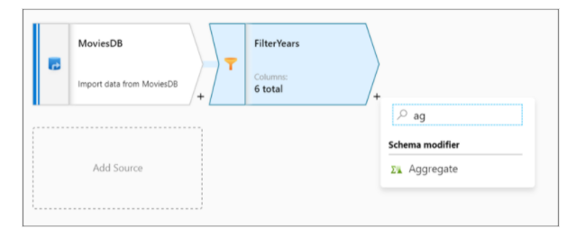

1. Name your aggregate transformation **AggregateComedyRatings**. In the **Group by** tab, select **year** from the dropdown to group the aggregations by the year the movie came out.
2. Go to the **Aggregates** tab. In the left text box, name the aggregate column **AverageComedyRating**. Click on the right expression box to enter the aggregate expression via the expression builder.
3. To get the average of column **Rating**, use the avg() aggregate function. As **Rating** is a string and avg() takes in a numerical input, we must convert the value to a number via the toInteger() function. This is expression looks like:

avg(toInteger(Rating))

Click **Save and Finish** when done.

1. Go to the **Data Preview** tab to view the transformation output. Notice only two columns are there, **year** and **AverageComedyRating**.
2. Next, you want to add a **Sink** transformation under **Destination**.
3. Name your sink **Sink**. Click **New** to create your sink dataset.
4. Choose **Azure Data Lake Storage Gen2**. Click Continue.
5. Choose **DelimitedText**. Click Continue.
6. Name your sink dataset **MoviesSink**. For linked service, choose the ADLS gen2 linked service you created in step 6. Enter an output folder to write your data to. In this tutorial, we're writing to folder 'output' in container 'sample-data'. The folder doesn't need to exist beforehand and can be dynamically created. Set **First row as header** as true and select **None** for **Import schema**. Click Finish.

Now you've finished building your data flow. You're ready to run it in your pipeline.

## Running and monitoring the Data Flow

You can debug a pipeline before you publish it. In this step, you're going to trigger a debug run of the data flow pipeline. While data preview doesn't write data, a debug run will write data to your sink destination.

1. Go to the pipeline canvas. Click **Debug** to trigger a debug run.
2. Pipeline debug of Data Flow activities uses the active debug cluster but still take at least a minute to initialize. You can track the progress via the **Output** tab. Once the run is successful, click on the eyeglasses icon to open the monitoring pane.
3. In the monitoring pane, you can see the number of rows and time spent in each transformation step.
4. Click on a transformation to get detailed information about the columns and partitioning of the data.

If you followed this tutorial correctly, you should have written 83 rows and 2 columns into your sink folder. You can verify the data is correct by checking your blob storage.